What to Bring
THEME: My Place
Bring plenty of images and ideas connected to My Place — these might be your own photographs or drawings, or images gathered from magazines and online sources. These references are simply starting points; through the printmaking process they will be transformed into something entirely your own.
The finished book will be approximately 19 × 26 cm (7.5 × 10.3 inches). Images should ideally be smaller, allowing space around them — around 15 × 20 cm (6 × 7.75 inches) works well — though full-page, bleed prints are also welcome.
Come prepared with curiosity, openness, and a willingness to explore — everything else will unfold in the studio.
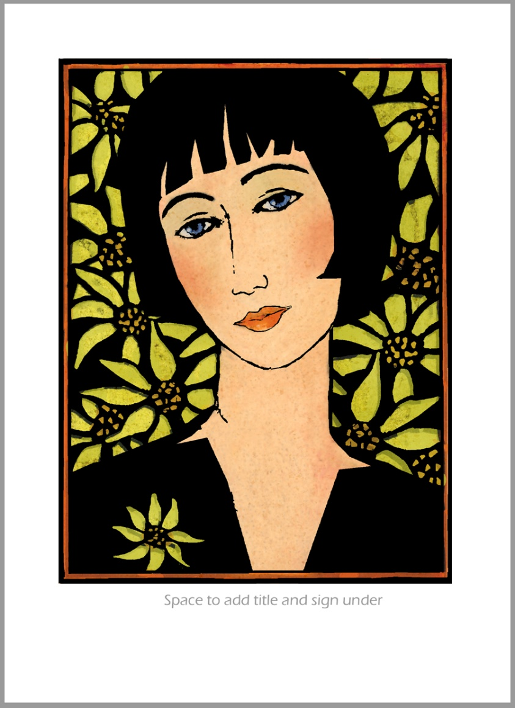

Bring an apron or old shirt – printmaking ink can be messy.

