Wrapt in Rocky 2012
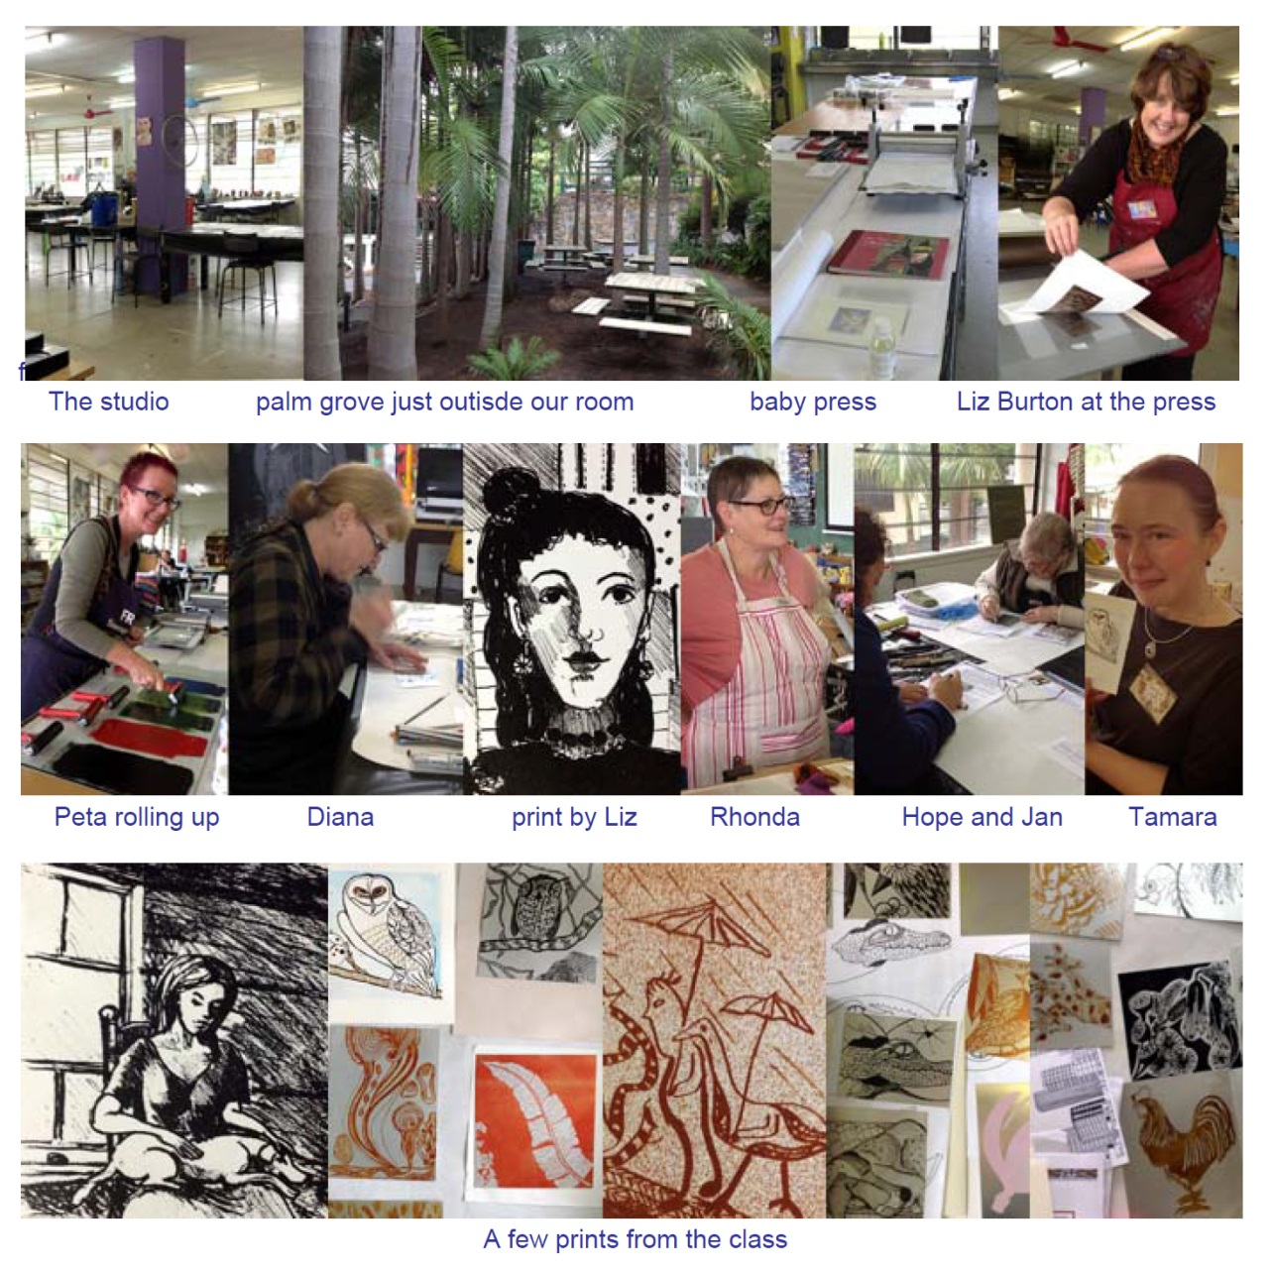
We are in the midst of our 5 day waterless lithography workshop for Wrapt in Rocky at the Girls Grammar School in Rockhampton, Central Queensland coast. Despite the unseasonal rain earlier in the week the sun is now shining and a beautiful landscape of mountain ranges and tropical plants is being revealed. The participants are mostly educators and practising artists so the imagery is pretty outstanding and lots of gorgeous prints are being created.
Read what one of the students wrote about the workshop:
The dust has settled and we are all looking for the equipment to do waterless such is our excitement!
I'll say it again – I really do think you both excelled yourself with the notes. They are brilliant, and I've seen a lot of notes over the years!!!! I've been in touch with almost everyone in the class and our sentiments are unanimous.
When I mentioned in this letter to everyone the generosity of your teaching, how structured and stream-lined you have it, how it empowers those who learn it to feel confident because it's so comprehensive, how you both pitch in with all the worst aspects of print making - cleaning up, helping anyone at any stage- and how we as students don't want for anything when we go to your class, again the responses were unanimous. Everyone commented on how successful it all was and the ways in which they felt they could utilise the techniques.
I know, by design, that your commitment to what you do is intentional but it's heartening to have that confirmed. Linda D

